LIEUTENANT COLONEL MICHAEL J. SHANE
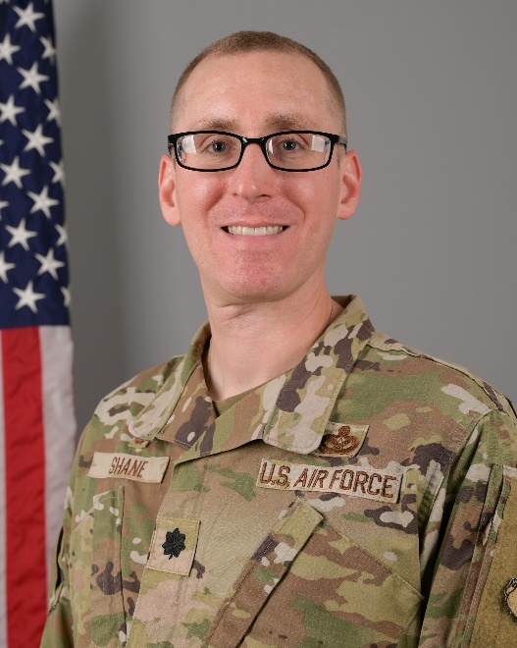

Lieutenant Colonel Michael J. Shane is the Commander, Air Force Reserve Officer Training Corps Detachment 290, University of Kentucky, Lexington, Kentucky. He leads a lethal team of 6 active duty cadre in training, educating, and transforming cadets from the University of Kentucky, as well as 8 corss-town universities, to be the Department of the Air Force’s next generation of officers and warfighters.

Lt Col Shane graduated from the University of Kentucky, Lexington, Kentucky in 2010 with a Bachelor of Science in Civil Engineering and commissioned through Air Force Reserve Officer Training Corps Detachment 290. He commissioned as a Developmental Engineer and cross-trained into the Civil Engineer career field in 2013 where he has held a variety of leadership, staff, and command positions at the squadron, group, wing, Major Command, and center levels.

Prior to his current assignment, Lieutenant Colonel Shane was the Commander, 1st Expeditionary Theater Sustainment Squadron, Al Udeid Air Base, State of Qatar where he led 53 Airmen in executing USCENTCOM’s largest construction portfolio, scoped at $10.6B across 3 countries.

EDUCATION

2010 Bachelor of Science, Civil Engineering, University of Kentucky, Lexington, KY
2010 Air and Space Basic Course, Maxwell Air Force Base, AL
2015 Salutatorian, Master of Fine Arts in Creative Writing, Full Sail University, Winter Park, FL
2015 Squadron Officer School, Maxwell Air Force Base, AL.
2023 Masters of Military Operational Art, Air Command and Staff College (IDE), Maxwell Air Force Base, AL

ASSIGNMENTS

1. October 2010 – September 2012, Project Engineer, Space Development and Test Directorate, Kirtland Air Force Base (AFB), NM
2. September 2012 – August 2013, Satellite Flight Test Engineer, Space Development and Test Directorate, Kirtland AFB, NM
3. August 2013 – September 2014, Chief, Facilities Engineering, Space Development and Test Directorate, Kirtland AFB, NM
4. September 2014 – October 2015, Readiness and Emergency Management Flight Commander, 8 Civil Engineer Squadron, Kunsan Air Base (AB), Republic of Korea
5. October 2015 – January 2017, Chief, Operations Engineering, 611 Civil Engineer Squadron, Joint Base (JB) Elmendorf-Richardson, AK
6. January 2017 – October 2018, Chief, Installation Management, 673 Civil Engineer Squadron, JB Elmendorf-Richardson, AK (October 2017 – April 2018, Director of Operations, 441 Air Expeditionary Squadron, Kobani Landing Zone, Syria)
7. October 2018 – July 2020, Chief, Civil Engineer Inspections, Air Force Global Strike Command Inspector General, Barksdale AFB, LA.
8. August 2020 – July 2022, Operations Flight Commander, 2 Civil Engineer Squadron, Barksdale AFB, La.
9. July 2022 – Jun 2023, Student, Air Command and Staff College, Maxwell AFB, AL.
10. June 2023 – August 2025, Operating Location Alpha Chief, Air Force Installation and Mission Support Center Detachment 2, Andersen AFB, GU
11. August 2025 – June 2026, Commander, 1 Expeditionary Theater Sustainment Squadron, Al Udeid AB, State of Qatar
12. June 2026 – Present, Commander, AFROTC Det 290, University of Kentucky, Lexington, KY

MAJOR AWARDS AND DECORATIONS

Meritorious Service Medal with two oak leaf clusters
Air and Space Commendation Medal with three oak leaf clusters, with “C” device
Air and Space Achievement Medal

OTHER ACHIEVEMENTS

2025 Air Forces Central Major General Gilbert Award
2024 Air Force Materiel Command Sijan Leadership Award
2020 2 Bomb Wing Flight Commander of the Year
2017 Society of Military Engineers Lupia Award

EFFECTIVE DATES OF PROMOTION

Second Lieutenant June 27, 2010
First Lieutenant June 27, 2012
Captain June 27, 2014
Major May 1, 2020
Lieutenant Colonel April 1, 2025

(Current as of July 2026)

